Topic 7
Founding and development of the United States
Name: ___________________ ( ) Class: __________

Key Learning Points
- Internal and external factors and impact of the American Revolution
- Territorial expansion, Westward Movement and Monroe Doctrine in the 19th-century US
- The US before and after the American Civil War
- Formation of different social migrant communities in the 19th century: using the experience of Chinese labourers as example (Extended part)

Timeline of historical events
1775-1783 | American Revolution
1776 | - Adoption of the Declaration of Independence  - Independence of the United States of America
1783 | Britain and the US signing the Treaty of Paris
1787 | Adoption of the Constitution of the United States of America
1789 | Formation of the US federal government
1823 | Issuance of the Monroe Doctrine
1861-1865 | American Civil War
1863 | Issuance of the Emancipation Proclamation
1882 | The US Congress passing the Chinese Exclusion Act

I Internal and external factors and impact of the American Revolution
By the 1730s, Britain had set up the Thirteen Colonies along the (a) ___eastern coast___ of North America. | 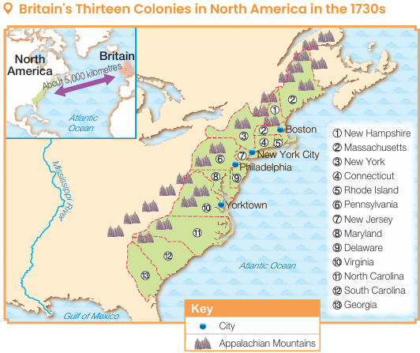
A Internal factors in the American Revolution
1. Discontent caused by British colonial policies
Heavy taxation sped up the colonies’ resistance
North Americans strongly protested against Britain tightening
(d) ___taxation___ in North America, ，claimed ‘no taxation without
(e) ___representation___ ’.
British colonial policies

Political aspect: Britain strengthening its control over the colonies
- Britain appointed (a) __governors___ to manage colonies in the North America.
- After the Seven Years' War, ，British sent more (b) ___troops___ to North America, leading to conflicts.

Dissatisfaction of the North Americans

Economic aspect
(c) ___Trade policies___ restricted the colonies' economic development.

2. Tradition of pursuing liberty
- People emigrated from European countries to the Americas to get away from religious or political (f) ___persecution___ .
- In the second half of the 18th century, North Americans could not tolerate the exploitation and oppression by Britain anymore. Therefore, they stood up and fought against British colonial rule.

B External factors in the American Revolution
Inspiring North Americans to resist

Inspiration from European revolutions
In the 17th century, (a) ___Dutch War of Independence___ and (b) ___Glorious Revolution ___ of Britain broke out.

Impact of the Enlightenment in Europe
In the 18th century, (c) ___Enlightenment ideas___ spread in North America, leading to the emergence of thinkers fighting for freedom and independence.

C Course of the American Revolution
March 1770
Happening of the Boston Massacre

December 1773
Being dissatisfied that the British East India Company could sell tea to the colonies duty-free, North American people poured the tea into the sea. This was known as the (a) ___Boston Tea Party__ .

January 1774
The (b) ___Intolerable Acts___ passed and tookaway the autonomy of Massachusetts.

September 1774

Representatives of the colonies held the (c) ___First Continental Congress___ .

April 1775
British troops started fighting with North American militias in Lexington. The (d) ___War of Independence__ broke out officially.

May 1775
The Second Continental Congress was held and (e) ___George Washington__ was appointed as the commander-in-chief.

July 1776
The North American colonies passed the (f) ___Declaration of Independence__ to form an independent nation in the name of (g)‘ ___The United States of America__ ’.

February 1778
France signed a treaty of alliance with the US, providing military aid for the latter. France even sent troops to North America to fight. The Continental Army gradually turned the tide.

October 1781
The British army was defeated in the (h) ___Battle of Yorktown___ .
September 1783
Britain and the North American colonies signed the (i) ___Treaty of Paris__ . Britain formally recognised the independence of the US.

D Results of the American Revolution
1. Birth of the United States of America
On 4 July 1776, the (a) ___Declaration of Independence___ was adopted, the (b) ___United States of America___ was founded.

2. Formation of the republican system
- In 1787, representatives of the Thirteen States adopted the (c) ___Constitution of the United States of America__ . The US has become a (d) ___federal republic___ .
- The (e) ___federal government___ handles national affairs, but the states could handle local affairs
- In 1789, (f) ___George Washington___ was elected as the first president.

Structure of the US federal government
The US federal government observes the principle of (g) ___separation of powers__ . These three branches have equal authority with checks and balances among them.

(h) ___Congress__
- Senate
- House of Representatives

(i) ___President__

Supreme Court
- Courts of appeals
- District courts
Legislative branch
Executive branch
Judicial branch
Constitution of the United States of America

E Significance of the American Revolution in history
1. Impact on the US: Laying the foundation for national prosperity and strength
The US has ensured sustained political stability since its founding and gradually developed into a
(a) ___great power__ .
2. Impact on Europe and even the world
Promoting the
(c) ___French Revolution__
The (d) ___Declaration of the Rights of Man and of the Citizen__ , which was published during the French Revolution, was deeply influenced by the Declaration of Independence.
The Declaration of Independence helping the spread of European Enlightenment ideas
It was the first political document that included liberty, equality and
(b) ___natural rights__ .

Prompting Britain to change
its colonial policies
Britain began to recognise the autonomy of other colonies and changed its colonial policies. For example, (f) ___Canada___ was allowed to become an autonomous territory.
Promoting independence movements
in (e) ___Latin America___
People of Central and South America launched revolutions to fight for independence.

II Territorial expansion, Westward Movement and Monroe Doctrine in the 19th-century US
Establishing a symbol of
liberty and democracy
(g) ___Statue of Liberty__ stands as a symbol of the spirit of liberty, democracy and independence.
Setting an example of the
republican system
The republican system provided valuable experience for other countries. For example,
(h) ___Sun Yixian__ referred to the US and set up a republican government.
A Territorial expansion in the 19th century US
Year | Territory | Way of acquisition
First stage
1783 | Land east of the Mississippi River and south of (a) ___Canada___ (from Britain) | (b) ___Signing a treaty___
Second stage
1803 | (c) ___Louisiana___ (from France) | (d) ___Purchase___
Third stage
1818 | Parts of today's North Dakota and (e) ___Minnesota___ (from Britain) | Signing a treaty
1819 | (f) ___Florida___ (from Spain) | Purchase
Fourth stage
1845 | Texas (from (g) ___Mexico___ ) | (h) ___Emigration___
Fifth stage
1846 | Today's (i) ___Oregon___ and Washington  (from Britain) | Signing a treaty
1848 | (j) ___California___ (from Mexico) | Using military force and purchase
Sixth stage
1867 | (k) ___Alaska___ (from Russia) | Purchase
Seventh stage
1898 | (l) ___Hawaii___ (from Spain) | Emigration
1899 | Puerto Rico and (m) ___Guam___ (from Spain) | (n) ___Using military force___
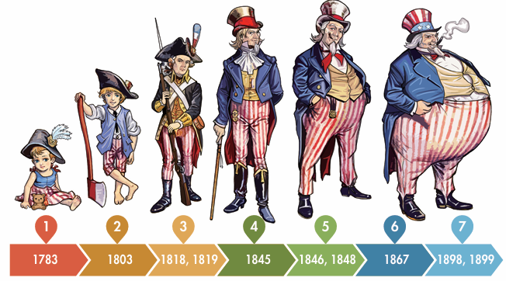
B Westward Movement
The westward migration of the US people and their exploration in the West from the late 18th century to the late 19th century.

1. Belief behind the Westward Movement: ‘manifest destiny’
- The Americans believed that all land from the (a) ___Atlantic___ to the Pacific Coasts should belong to the US.
- White people believed that (b) ___God___ had given them a mission to spread
(c) ___Christianity___ , liberty and democracy to the West.

2. First stage of the Westward Movement: from the late 18th century to the mid-19th century
Background: the tradition of exploring inland regions
During the colonial period, North Americans had already been exploring lands west of the
(d) ___eastern coast___ .
Results
By 1850, the whole West had basically become part of the US territory.
Development
Formulating land policies to develop the land in the West
- Land Ordinance of 1784: The government took over the ownership of the territories west of the (e) ___Appalachian Mountain___ .
- Land Ordinance of 1785: The government sold lands in the West at a low price.
- Northwest Ordinance of 1787: The region would become a new state once the population of the territory northwest of (f) ___Ohio River___ had exceeded 60,000.
Developing transport to promote the development of the West
- The (i) ___Cumberland Road___ became the door for people from the East Coast to the West.
- The (j) ___Erie Canal___ was the first canal connecting the East Coast and the West.
Displacing American Indians to create farmland in the West
(g) ___Indian Removal Act___ (1830) took away American Indians' land ownership within US territory and forced them to migrate to the west of the
(h) ___Mississippi River___ . Their land was sold to the whites.

3. Second stage of the Westward Movement: from the mid-19th century to the late 19th century
Background
California Gold Rush
In 1848, gold mines were discovered in (a) ___California___ . A (b) ___gold rush___ began, a large number of people moved in.
Influx of European immigrants
In the 1850s, large numbers of (c) ___Europeans___ immigrated to the US due to political unrest and famine. Some headed west to make a living.

Development
Speeding up land distribution to promote agricultural development
Under the (d) ___Homestead Act___ , by farming the government's lands for five years or more, people could be granted the ownership of the land they farmed.
Promoting industrialisation to lay the foundation for becoming
an industrial power
- Silver, copper and (h) ___coal___ mines were discovered in many states in the West.
- By the late 19th century, the West had become the centre of US (i) ___textile___ and steel industries. It provided raw materials for (j) ___car manufacturing___ in the East.
Developing rail transport to
connect to the East
In 1869, the first US (g) ___Transcontinental Railroad___ began its service, promoting population and economic growth in the West.
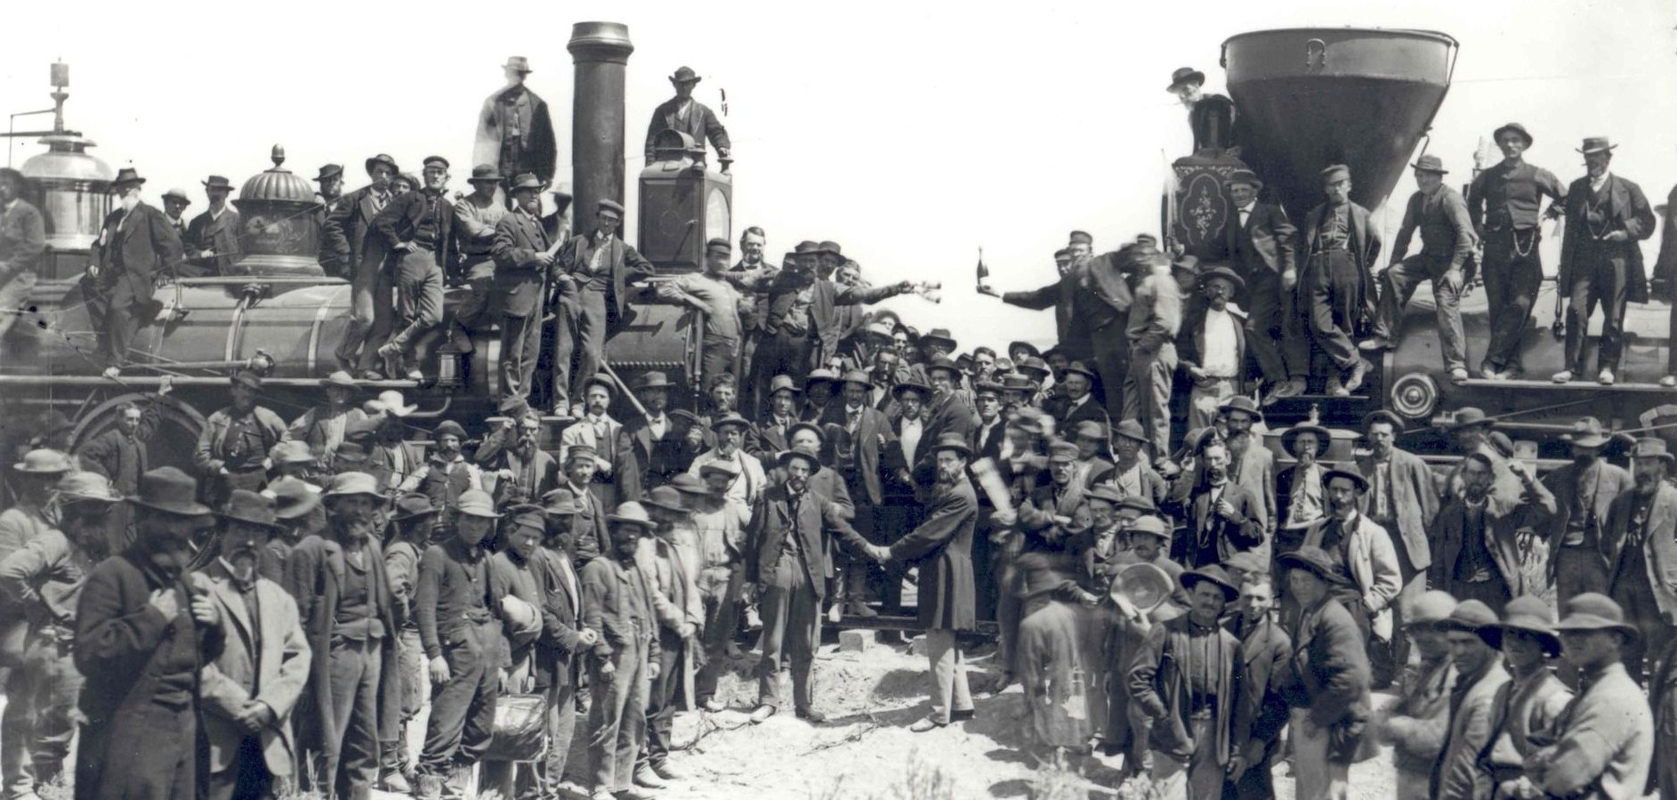
Waging wars against American Indians to take absolute control of the West
- Since the 1860s, the federal government had kept sending troops to attack (e) ___indigenous tribes___ Their population decreased rapidly. They were monitored by the government in their assigned (f) ___reservations___ .
- In the 1890s, the federal government had gained full control on all the lands in the West.

Results
- In 1890, the federal government abolished the term (k) ‘ ___frontier___ ’, declaring that there was no more obvious boundary for exploration.
- The Westward Movement came to an end.

C Monroe Doctrine
Basic principles of US diplomacy that were proposed by US president (a) ___James Monroe___ and implemented in the US from the early 19th to the 20th centuries.
Monroe

- The US adopted (b) ___isolationism___ and refused alliance with other countries to avoid getting into the European conflicts.
- European countries tried to help (c) ___Spain___ to recover its colonies in Latin America, which threatened the safety of the US.

1. Main content
- No country might establish new (d) ___colonies___ in the Americas.
- Interventions of any kind by European powers in Latin America would be considered a direct threat to the (e) ___security___ of the US, , and the US would seek (f) ___revenge___.
- The US would not interfere with the existing European (g) ___colonies___ .It would also stay away from the affairs of European powers.

2. Significance on the development of the US
Promoting  territorial expansion | In 1848, US president (h) ___James Polk___ announced that the US must speed up its westward territorial expansion.
Including Latin America into the  sphere of influence | - The US successfully blocked European intervention in the Americas which ensured the influence of the US over  (i) ___Latin America___ .  - In 1904, US president (j) ___Theodore Roosevelt___ stated that the US has the right to intervene in the (k) ___internal affairs___ of Latin American countries if necessary.
Consolidating isolationism | The US kept staying away from European affairs to secure stable domestic (l) ___economic___ development.

III The US before and after the American Civil War
Between 1861 and 1865, a civil war broke out in the US. The warring sides were the (a) ___slave states___ in the South and the (b) ___free states___ in the North.
A Main causes of the American Civil War
1. Power struggles between the federal government and the states
(a) ___Federalists___
Supported federalism, believing that the (b) ___federal government___ should have higher powers over the states.
(c) ___Anti-federalists___
Against federalism, believing that (d) ___ states___ ' rights should come first.
Kentucky and Virginia Resolutions
In 1789, anti-federalists strongly opposed bills passed by Congress regarding (e) ___foreign immigrants___, sparking a political controversy.
Signs of (f) ___splitting___ between the North and the South came to surface.

Rivalry

2. Significant differences between the North and the South
 | Controversy over trade measures
 | The North | The South
Main industry | Mainly (g) ___industrial___ with various types of factories | (Mainly (i) ___agricultural___ , such as cotton farming
Demand for black slaves | Low. Factories mainly recruited new immigrants as labour. | High. The owners of (j) __plantations__ bought large numbers of black slaves as labour.
Stance on trade | Supported (h) ___trade protectionism___ and favoured high tariffs. | Supported (k) ___free trade___ and favoured low tariffs
Conflicts caused by slavery
- The North believed that slavery violated the
(l) ___Declaration of Independence___ and abolished slavery. The North also opposed further expansion of slavery in the South.
- The cotton farming in the South relied heavily on the (m) ___black slaves___ . Slavery was deeply-rooted.
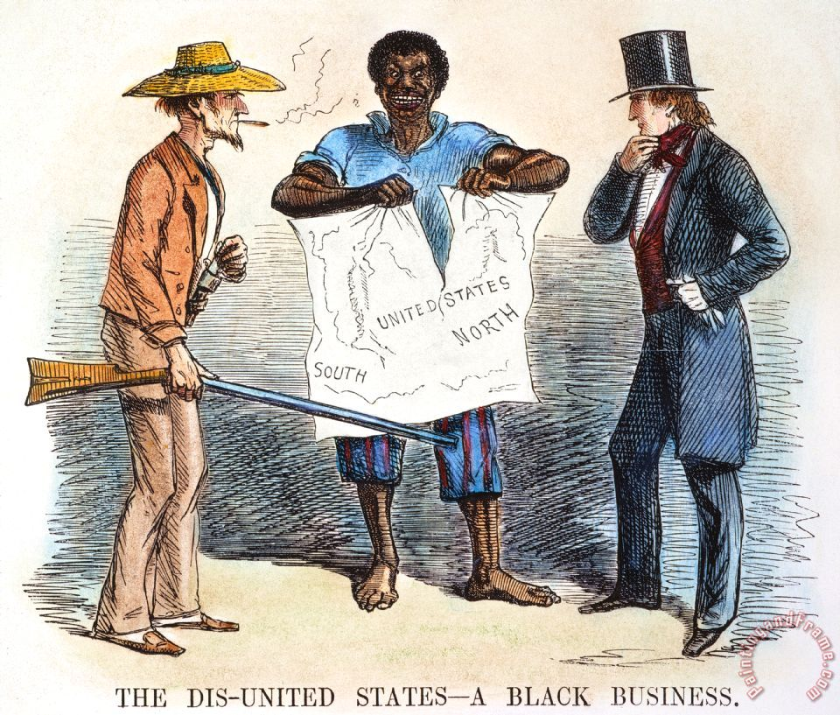
US cartoon published in 1856
Disputes over the new territories during the Westward Movement
Missouri Compromise (1819)
- (n) ___Missouri___ was ready to become a new state. The North and the South were competing against each other.
- Both the North and the South agreed to have Missouri joined the US as a (o) ___slave state___. Meanwhile, (p) ___Maine___ would split from Massachusetts as a free state and new free states in the North would not be slave states.

Bleeding Kansas (1854-1861)
- In 1854, the Congress allowed people in (q) ___Kansas___ to decide to be a free or slave state by voting.
- Between 1854 and 1861, Kansas was often the site of (r) ___violent struggles___. The conflicts between the North and the South were greatly deepened.

B Course of the American Civil War
1860
1861
1865
American Civil War
(a) ___Abraham Lincoln___ who opposed slavery, was elected the President.
In April, the army of the Confederacy in the South fired at the army of the Union. The
(d) ___American Civil War___ officially broke out.

In February, the (b) ___Confederate States of America___ was formed in the South and confronted the (c) ___United States of America___ in the North. The North and the South formally split.
In April, the (e) ___army of the Confederacy___ surrendered. The US was unified again.

C Impact of the American Civil War
1. End of slavery
- In 1863, (a) ___Emancipation Proclamation___ was issued, declaring that all black slaves from the Confederacy in the South were free.
- In January 1865, (b) ___Thirteenth Amendment___ to the US Constitution was passed, abolishing slavery nationwide.
2. Reconstruction of the South
National reunification
Southern states returned to the (c) ___Union___ . There was no more civil war in the US since then.
Establishment of the (d) ___Freedmen's Bureau___ (1865)
It offered black people (e) ___food___ and clothes, and helped them to find jobs, assisting them to adapt to the society.
Protection on the rights of black people
- The Fourteenth Amendment (1868) protected the (f) ___citizenship___ of the black people.
- The Fifteenth Amendment (1870) granted (g) ___voting right___ to black males.
Reconstruction of social and economic development
- Established the first (h) ___public school___ system in US history and increased the chance for black people to receive education.
- Rebuilt roads and bridges destroyed during the war, helped with the funding of
(i) ___railway___ construction.

3. Facilitation of the Westward Movement
After returning to normal lives, a lot of soldiers migrated to the West with their families. The freed (j) ___black slaves___ also moved to the West. These additional population contributed to the further development of the Westward Movement.

4. Rapid industrialisation
(k) ___Railway___ construction promoted various industrial and business opportunities. The US became the world's largest industrial power by the late 19th century.
IV Formation of different social migrant communities in the 19th century: using the experience of Chinese labourers as example (Extended part)
A Factors in Chinese immigration to the US
Political instability in China causing the Chinese to find a way out abroad
China was defeated in the two external (a) ___Opium Wars___, and struggled to pacify the internal (b) ___Taiping Rebellion___ , prompted people in southeastern coastal areas to travel across the oceans to the US to make a living.
Changes in the sea ban policy leading to Chinese immigration to the US
In 1868, China and (e) ___the US___ signed the treaty allowing the Chinese to immigrate freely to the US.
Labour shortage in the US prompting a large need for Chinese labourers
After the (c) ___American Civil War___ , the US faced a (d) ___labour___ shortage.

B Experience of early Chinese labourers in the US
Chinatowns
- Chinese labourers usually first arrived in (a) ___San Francisco___ (also known as Old Gold Mountain) in California to enter the US.
- To take care of one another and achieve a sense of security, they often lived together.

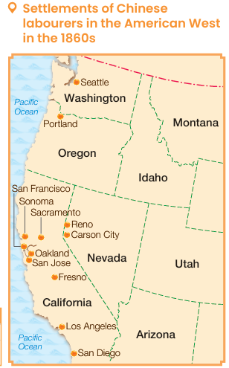

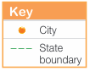

Fields of work
Railroad construction
About 20,000 Chinese labourers participated in the construction work of the western section of the (b) ___first Transcontinental Railroad___ , accounting for 90% of all workers involved.

Mining
In the second half of the 19th century, most of the (c) ___gold___ production in the US was contributed by Chinese miners.

Agriculture
Chinese labourers mainly cultivated in (d) ___California___ , turning
(e) ___swampland___ into farmland. They contributed a lot to the agricultural development of the American West.

Working in factories
Since the 1860s, thousands of Chinese labourers had worked in various types of factories, such as (f) ___cigar factories, cotton mills, Chinese labourers working in an orange plantation garment factories, footwear factories___, etc.

Providing services
- A large number of Chinese labourers were employed by American
(g) ___families__ to help with cooking and housework.
- Many of them also worked in (h) ___laundries__ .

Chinese associations
- Formed the (i) ___huiguan___ in accordance with their native origins, to help Chinese labourers to adapt to the new life in the US.
- Provided services like medicine, education, and helped to resolve
(j) ___disputes___ .

Racial discrimination
- In 1852, California introduced a (n) ___poll tax___ on Chinese miners.
- In 1882, the US Congress passed the (o) ___Chinese Exclusion Act___ , banning overseas Chinese from migrating to the US and Chinese in the US from becoming citizens.
Customs
- They only spoke (k) ___Cantonese___ , Taishanese or Hakka dialect.
- The men (l) ___kept their pigtails___.
- Worshipped (m) ___Tin Hau___ and Kwan Tai.

